Leadership Styles Instructions
Springfield College
Nancy……….
27th June 2021
Part 1:
Write about your preferred leadership style.
My preferred leadership style is the participative style of leadership. This type of leadership style is much rooted in democracy. It involves a team of experts to make a decision. It makes all those under this kind of leadership involved and contributing to the decision despite the leader always having his or her last word in the process of making a decision. Its advantages include increased employee job satisfaction as well as motivation, the creation of a strong team, and an increased level of productivity. The participative style of leadership also tends to encourage creativity among employees.
Its disadvantages include the prolonged process of making decisions, leaders apologizing to the employee, and sometimes poor decisions (Leadership $ General Management, 2021).
Part.2
Complete style quiz found at: https://www.leadershipiq.com/blogs/leadershipiq/36533569-quiz-whats-your-leadership-style Take a screenshot of your results and add to the bottom of word document assignment
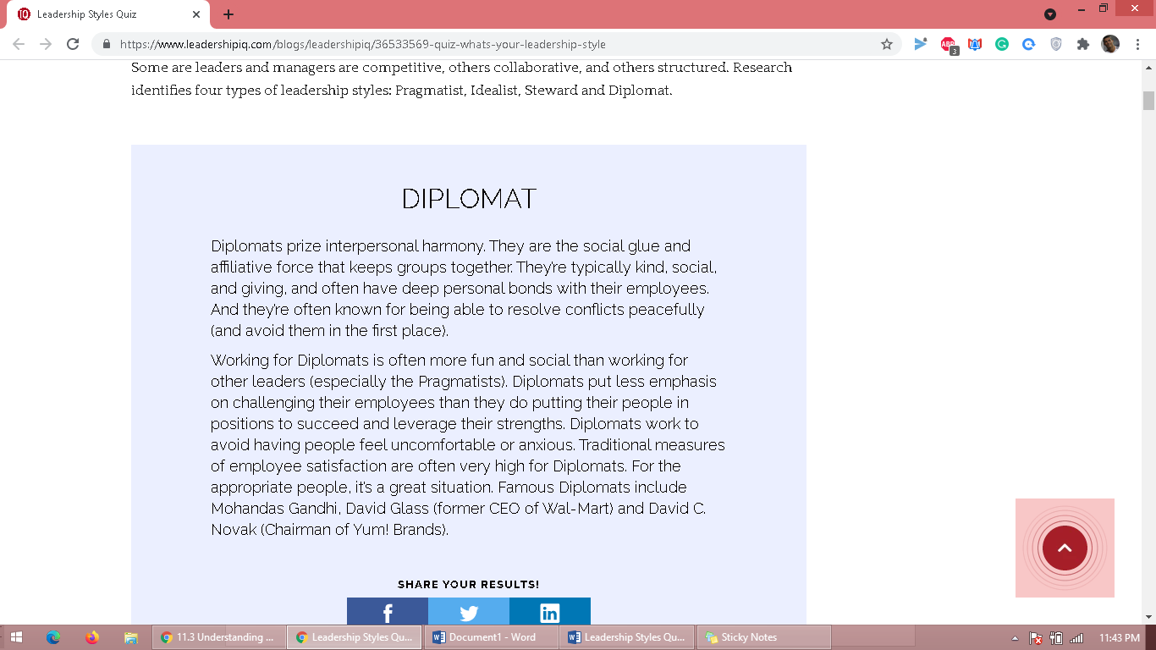
Part 3:
Does your preferred style match up with your quiz results? If yes, how? If no, why not?
Yes, the result matches up with my leadership style. My leadership style being participative, it is much associated with being kind, social, and giving together with maintaining a deep personal bond with my all employees. Same as Diplomats, my style of leadership involves peaceful conflict resolution and if possible avoiding them in order to maintain a good relationship with all those in the organization or company. The participative leadership style aims at always making employees comfortable and less anxious. This remains to be what diplomats work for always to avoid making people anxious or feel uncomfortable. Also, my style of leadership tends to have less emphasis on challenging people/employees but instead puts them in positions which they can always experience success as well as leverage their own strengths. This same is always what diplomats do while with their employees or any other person.
Reference
Leadership $ General Management (2021): The five-leadership style you can use. Retrieved on 27 June 2021. https://www.imd.org/imd-reflections/reflection-page/leadership-styles/

